Climate Change and Animal Agriculture

G.S.L.H.V. Prasada Rao and G. Girish Varma
Centre for Climate Change Adaptation to Environment and Climate Change Studies
Kerala Veterinary and Animal Sciences University
Mannuthy, Thrissur – 680 651, Kerala, India
gslhvprao@gmail.com

Global warming is the biggest long term threat to life on earth. Rise in temperature may drive thousands of species to extinction, trigger more frequent floods and droughts and sink low lying islands and coastal areas by rising sea levels. It is the result of rising atmospheric content of CO₂ mainly owing to burning of hydrocarbons or fossil fuels like as petrol and diesel. Destruction of forests and their degradation too contribute to rise in carbon dioxide levels. The IPCC (2006) projected the rate of warming for the 21st century to be between 0.8 and 4.4ºC at various stabilized CO₂ levels in atmosphere and it is most likely to be 3°C by the end of this century. It could cost global economy almost $7 trillion by 2050, is equivalent to a 20% fall in growth if no action is taken on greenhouse gas emissions. If action is taken, it will cost only $350 billion due to climate change already taken place, just 1% of the global GDP. The winter 2007 was the warmest and recorded 0.85ºC above average of 12ºC and the previous highest was 0.71ºC, which occurred in 2002 in Northern Hemisphere. The entire Europe Union recorded the warm winter, having more than 2ºC above average. New York experienced the highest temperature of 21.7ºC on a day in January, 2007 and the second highest was recorded as 17.2ºC in 1950. The year 2007 was the warmest winter in the NHS. However, floods and excess rains were also noticed due to hurricanes and tropical storms worldwide in 2007. The year 2010 was the warmest year in India, followed by 2009. It was the second warmest year globally after 1998. It was also one of the wettest years globally in recent years and it was a landmark in annals of climatology. Out of 10 years in the first decade of this century, 8 warm years took place in India except in 2005 and 2008 while 9 globally. 1998 was the warmest, followed by 2010 across the World. Several continents experienced floods too while heat wave and drought during summer in Russia. Cloud bursts in Pakistan and India led to devastating floods in August. Snow storms in the United States and the European Union were noticed. Heavy rains poured during the Northeast monsoon in southern States of India. As a whole, cereals production was adversely affected in the respective regions the World over and thus escalation in foodgrains price.
The Indian economy is mostly agrarian based and depends on onset of monsoon and its further behaviour. The year 2002 was an example to show how Indian foodgrains production depends on rainfall of July and it was declared as the all-India drought, as the rainfall deficiency was 19% against the long period average of the country and 29% of area was affected due to drought. The kharif foodgrains production was adversely affected by a whopping fall of 19.1%. Similar was the case during the monsoon season in 2009 and 2012. Occurrence of droughts and floods during South West monsoon across the Country affects foodgrains production to a greater extent. It is one of the reasons that the foodgrain production is not in tune with plan estimates and the foodgrains production is likely to touch only a maximum of 260 million tonnes by 2020 at the present rate though it is projected as 400 million tonnes to declare India as one of the developed countries.
The increase in all-India mean temperatures is almost solely contributed by increase in maximum temperature (0.6ºC/100years) with minimum temperature remaining practically trendless. Consequently, there is a general increase in diurnal range of temperature. The rate of increase was more during the post monsoon season (0.87⁰C), followed by 0.72⁰C in winter. Across different zones of the Country, the rate of increase was more in West Coast of India, followed by the Western Himalayas of India. In rainfall, there was a decrease since last 50 years. It appears that rainfall cycle is advanced by two weeks since increase in rainfall was noticed during May and June while declined in July and August in Northwest, West and Eastern parts of the Country. A marked increase in rainfall and temperature is projected in India during the current century. The maximum expected increase in rainfall is likely to be 10-30% over central India. Temperatures are likely to increase by 3 - 4 ºC towards end of the Century. It is more pronounced over Northern parts of India. In recent years, increase in night temperature during winter months was noticed in southern states of the Country.
Climate Change and Animal Agriculture
The State of Kerala always appears to be greenery due to high monsoon rainfall and thick vegetation. At the same time, the central and northern districts of Kerala experience prolonged dry spell from November to May if pre-monsoon showers fail. For the first time, the unprecedented summer drought was noticed across the State of Kerala in 1983. Similar drought was noticed in summer 2004 and 2013.The water levels were very low in major reservoirs wherever summer drought was prevalent. Surface water resources were dried up. Dairy farming is adversely affected due to lack of fodder and water in several districts across Kerala during the summer drought in 2013.
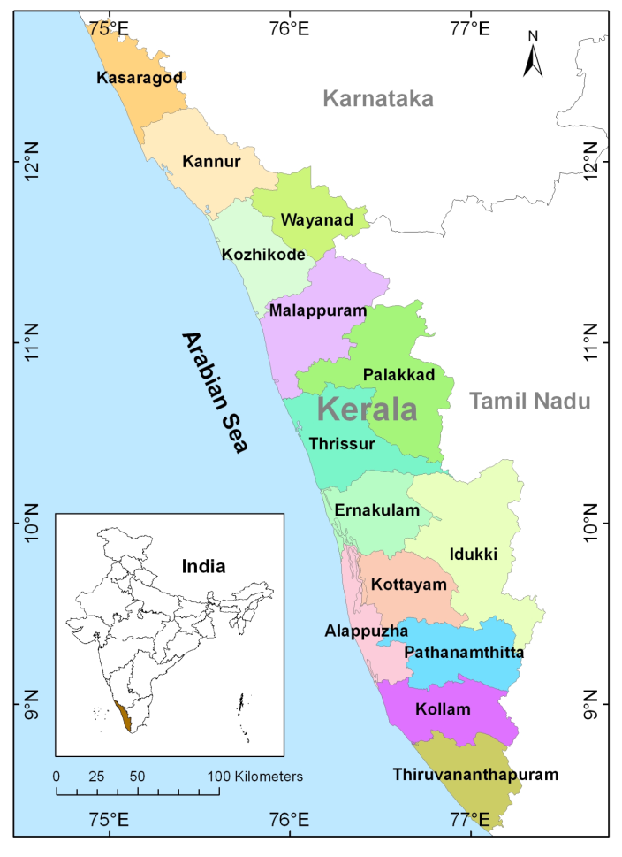
Decline in wetlands, forest area and increase in forest fires, indiscriminate land filling and sand mining, groundwater depletion, drying of streams, rivers and surface wells, floods and droughts, landslides, cloud bursts, rainfall decline, temperature rise (Fig. 1) are the issues related to climate change. The State of Kerala was moving from wetness to dryness within the humid climates (Fig.2). It is likely to be a threat to the society linked sectors like animal agriculture, agriculture, forestry, biodiversity, water resources and health. Sea level rise is another important climate change related issue along the Kerala Coast. Saline water intrusion and water quality is deteriorated in many parts of Kerala along the Coast and their impact in Animal Agriculture need to be understood. The occurrence of summer droughts and floods during monsoon season is not uncommon across the State of Kerala. Reports indicate that such weather abnormalities are likely to occur and reoccur under the projected climate change scenario. Thermal stress is noticed on cattle, poultry and elephants during summer due to high maximum temperature that prevails between 35 and 40 degree Celsius. The seasonal fluctuations are predominant in fodder availability and milk production (Fig. 3). One of the reasons for low milk production during summer in cattle is due to thermal stress and poor intake. The mortality rate in poultry could be explained again due to heat load though the rate of mortality is relatively less in Kerala when compared to other States, where heat wave during summer is a threat. However, the egg size, egg number, fertility, hatchability and feed conversion ratio are adversely affected. In detail studies in this direction is already on.

Fig. 1 Temperature trends over Kerala from 1961 to 2009

Fig. 2 Climate shifts in Kerala from 1901 to 2009
Initial studies indicated that installation of sprinklers on roof-top reduces inside temperature, by which the birds feels comfortable during summer and the mortality is minimised in poultry. The disease outbreak (like duck plague, duck cholera, fowl cholera) was noticed during summer 2013 and heavy mortality was noticed up to 50 per cent.
Fig. 3 Average milk production at ULF Mannuthy
In contrast, high rainfall with high relative humidity for more number of days during monsoon season leads to diseases. Of course, animal diseases that are prevalent mostly season bound and detail studies are to be taken up on mission mode for sustenance of animal agriculture under the Humid Tropics.
Climate Change and Poultry Industry

The poultry farming is very sensitive to heat stress. Egg production and size is likely to reduce in high summer temperature. It may not be that much severe in the Humid Tropics when compared to that of arid and semi-arid regions. However, increase in the egg production is hindered and it is reduced by 5% due to thermal stress even in the Humid Tropics. If there is no sprinkler, reduction in egg production could have been around 10%. The sprinkler reduces the poultry house temperature by 2-3°F. High summer temperature led to reduction in egg weight from 52 grams to 45 grams. This problem is reduced by providing more protein in the feed and also supplementation of aminoacids like methionine. The fertility of the eggs received at Revolving fund hatchery was reduced from 95 % to 75 % due to the hot summer. The hatchability also reduced from 85 % to 50 % on total egg set in the Revolving fund hatchery. It led to the closure of the Revolving fund hatchery in the remaining period of summer.
Increase in Disease Outbreak and Mortality

A poultry farmer ‘Basheer of Thrissur district’ although he vaccinated all 8000 ducklings for duck plague, due to summer stress the immunity did not develop which led to the outbreak of duck plague and loss of 50% (4,000) of his ducklings (45 days old) due to the outbreak of duck viral hepatitis (duck plague) in April and May 2013. Another farmer ‘Varghese of Thrissur’ lost around 1000 ducklings (3 months old) out of 7000 due to pasteurellosis outbreak in April, 2013. There was a mortality of 8 pullets out of 700 pullets reared in cages due to heat stroke accompanied by AI (Artificial insemination) stress at Poultry Farm, Mannuthy. The same thing had happened in a commercial broiler breeder farm with the mortality of 250 birds due to heat stroke and AI stress. The heat stress can be alleviated by providing cool water by installing sprinklers at roof top.

Models on global warming indicate that the rise in temperature is likely to be around 3 º C by end of this century. It is likely that the extreme weather events like droughts and floods, cold and heat waves increase in coming decades. The global economy will be adversely affected as mentioned in the latest report of IPCC. If the sea level increase as projected, the coastal areas which are thickly populated will be in peril and for the existing population, the safe drinking water will be a great problem. The whole climate change is associated with increasing greenhouse gases and human- induced aerosols and the imbalance between them may lead to uncertainty even in year-to-year monsoon behaviour over India. Therefore, there should be a determined effort from developed and developing countries to make industrialisation environment-friendly by reducing greenhouse gases pumping into atmosphere. In the same fashion, awareness programmes on climate change and its effects in various sectors viz., animal agriculture, agriculture, health, infrastructure, water, forestry, biodiversity and sea level and the role played by human beings in climate change need to be taken up on priority. In the process, life style of people should be changed so as not to harm Earth-Atmosphere continuum by pumping CFCs into atmosphere. From the animal agriculture point of view, effects of extreme weather events on important animal species are to be documented so that it will be handy to planners and weather insurance agencies in such reoccurrence events for mitigating the ill effects. Also, there is need to guide planners on projected future animal products’ scenarios including dairy farming based on climate change events, which will be more realistic at field level as models always overestimate the impacts. Finally, we have to foresee these extreme events and prepare ahead to combat them so that the losses can be minimised. In this direction, livestock advisory based on weather forewarning will go a long way for sustenance of animal agriculture. It is high time to institutionalize awareness programmes on climate change/variability effects in animal agriculture in varied climates on research mode as a part of World Universities Network

The State of Kerala always appears to be teaming with greenery due to high monsoon rainfall and thick vegetation. At the same time, the central and northern districts of Kerala experience prolonged dry spell from November to May if pre-monsoon showers fail. Decline in wetlands, forest area and increase in forest fires, indiscriminate land filling and sand mining, groundwater depletion, drying of streams, rivers and surface wells, floods and droughts, landslides, cloud bursts, rainfall decline, temperature rise are the issues related to climate change. The State of Kerala was moving from wetness to dryness within the humid climates. It is likely to be a threat to the society linked sectors like animal agriculture, agriculture, forestry, biodiversity, water resources and health. Sea level rise is another important climate change related issue along the Kerala Coast. Saline water intrusion and water quality in many parts of Kerala and their impact on the above sectors need to be addressed. Based on the recent reports, the sea level rise along the Kerala Coast was 1.73 mm/year. The projections in sea level rise are likely to go up since ice in the Polar Regions is melting very fast due to global warming. As per IPCC (2007), the rise in sea level was 12 to 22 cm during the last century and steadily increased till 2003, but since then the rise is slower. But in the Indian Ocean, higher sea level rise was noticed from 2004 to 2009. Increasing temperatures due to climate change has detrimental effect on animal productivity especially on exotic and crossbreds. About 97% of the cattle population in Kerala comprises of Crossbreds and such large crossbred population evolved as result of crossbreeding native cattle and exotic cattle of temperate climate should give us an opportunity to study the adaptation and acclimation aspects of cross breeding.

Ozone Depletion and UV Radiation
The greatest concentration of ozone is at an average in height of 25 km and above in the stratosphere. The ozone molecule is made up of three atoms of oxygen. It is the most efficient absorber of ultraviolet radiation from sun and thus protects all life forms in planet earth. Ozone depletion due to industrialization in recent decades is the concern of humankind and biological activities. Release of compounds like chlorofluorocarbons (CFCs), carbon tetrachloride and methyl chloroform could significantly deplete ozone layer that shielded the planet from ultraviolet radiation. The CFCs are used in a variety of industrial, commercial, and household applications. These substances are non-toxic, non-flammable and non-reactive. They are used as coolants in commercial and home refrigeration units, aerosol propellants and electronic cleaning solvents. The global average thickness of ozone is 300 Dibson units, equivalent to 3mm. In contrast, it is about 100 Dibson units, which alarm us that we are in great danger if precautionary steps are not taken up. The ozone level fell to 90 Dibson Units, which was the lowest value recorded on 30-09-98 nearly equalled to the lowest value ever recorded 88 Dobson Units on 28-09-94 over Antarctica. The ozone losses are caused by chlorine and bromine compounds released by chlorofluorocarbons and halons. Year-to-year variation of size and depth of ozone hole depend on variations in meteorological conditions. The unusual cold temperature by 5-9 ºF over Antarctic zone enables greater activation of reactive chlorine that ultimately causes more ozone loss and lower ozone levels. Increase in chlorine levels should peak in the Antarctic stratosphere within a few years (Shashi et al., 2002). Among UV radiations, UV-B radiation in the range of 280-320 nm is more sensitive to ozone fluctuations and reaches earth surface. A global network is created to monitor UV-B filtered radiation in terms of Minimum Erythema Dose (MED). The human-made interventions in industrial development lead to ozone depletion, thereby filtered UV radiation reaches the ground, resulting in various human, animal and crop diseases. The ozone loss has the potential to increase incidence of skin cancer, cataracts and damage to people’s immune system, harm some crops and interfere with marine life. However, little is known on impact of ozone depletion and increasing UV-B radiation on ontogeny of tropical plants and human and animal diseases since studies in this direction are lacking. Because CFCs remain in the atmosphere for100 years, continued accumulation of these chemicals pose ongoing threats, even after their use is discontinued.
Deforestation and Biodiversity
The natural forest utilizes about 686 Giga tonnes of carbon- about 50 per cent more than atmosphere – is being cleared at an average rate of about 13 million hectares per annum over the World. It makes deforestation responsible between 20 and 25 per cent of global greenhouse gas emissions. As many as 572 fires broke out in the forest of Kerala during 2004 summer and the average loss of forest per year during the last decade (1991-2003) came to about 2,093 ha. Severe droughts, high temperature and low relative humidity are the atmospheric factors responsible for forest fires in addition to human interventions. The Economic Review, prepared by the State Planning Board, 2003 warns that a third’s of State’s biodiversity would vanish or would be close to extinction by 2030 unless steps are taken to check extinction of species. Of the 300 rare, endangered or threatened species in the Western Ghats, 159 are in Kerala. Of these, 70 are herbs, 23 climbers, eight epiphytes, 15 shrubs and 43 trees. Besides, 10 species of fresh water fish are identified as most threatened. Kerala has a flora of 10,035 species, which represents 22 per cent of Indian flora. Of these, 3,872 are flowering plants of which 1, 272 are endemic. As many as 102 species of mammals, 479 birds, 169 reptiles, 89 amphibians and 262 species of fresh water fish are reported from Kerala. Many of these are endemic. The review recalls that during the 20th century, at least 50 plant species have become extinct in the Country. Three species of birds-Himalayan Mountain Quail, forest spotted owlet and pink-headed duct-have become extinct. Besides, as many as 69 bird species have been categorised as extinct. The mammals, Indian Cheetah and lesser one horned rhinoceros have also perished. The Malabar civet is on the threshold of extinction and 173 species have been listed as threatened. It may be noted that nearly 23 per cent of the total endemic flora species of the Country are in Kerala. Describing a conservation strategy, the review says that ecologically sensitive areas have to be identified with reference to topography, hydrological regimes and this has to be networked with species diversity.
Impacts of Droughts and Floods
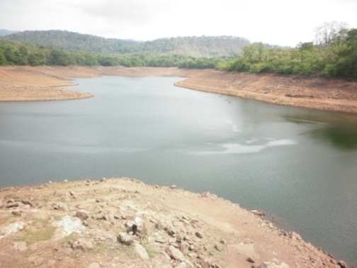
The occurrence of summer droughts and floods during monsoon season is not uncommon across the State of Kerala. Reports indicate that such weather abnormalities are likely to occur and reoccur under the projected climate change scenario. For the first time, the unprecedented summer drought was noticed across the State of Kerala in 1983. Similar drought was noticed in summer 2004 and 2013. The water levels are very low in major reservoirs wherever drought is prevalent. Surface water resources are dried up. Dairy farming is adversely affected due to lack of fodder and water in several districts during the current summer 2013.
Unprecedented low water level in Peechi Dam due to Hydrological Drought during summer 2013
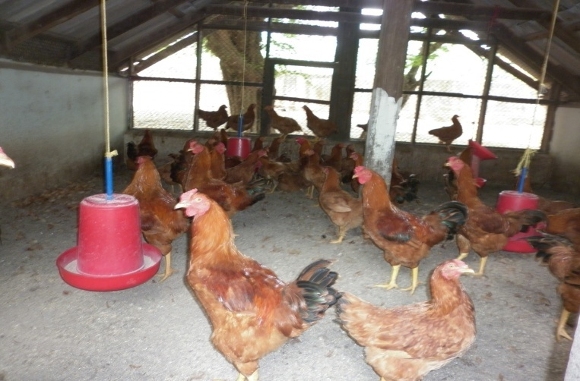
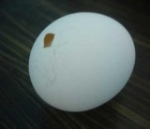
Thermal stress is noticed on cattle, poultry and elephants during summer due to high maximum temperature that prevails between 35 and 40 degree Celsius. The seasonal fluctuations are predominant in fodder availability and milk production. One of the reasons for low milk production during summer in cattle is due to thermal stress and poor intake. The mortality rate in poultry could be explained again due to heat load though the rate of mortality is relatively less in Kerala when compared to other States, where heat wave during summer is a threat. However, the egg size, egg number, fertility, hatchability and feed conversion ratio are adversely affected. In detail studies in this direction is already on. Initial studies indicated that installation of sprinklers on roof-top reduces inside temperature, by which the birds feels comfortable during summer and the mortality is minimised in poultry. The disease outbreak (like duck plague, duck cholera, fowl cholera) was noticed during summer 2013 and heavy mortality was noticed up to 50 per cent. In contrast, high rainfall with high relative humidity for more number of days during monsoon season leads to diseases. Of course, animal diseases that are prevalent mostly season bound and detail studies are to be taken up on mission mode for sustenance of animal agriculture under the Humid Tropics.
Egg size and quality are likely to be adversely affected due to global warming and climate change
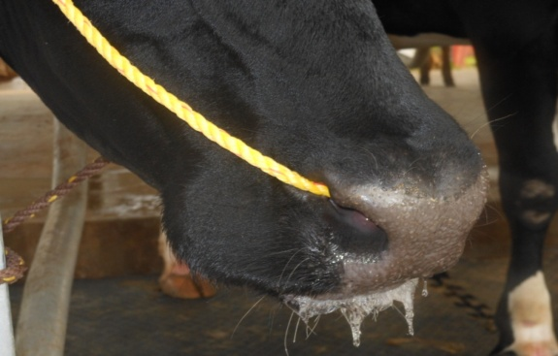
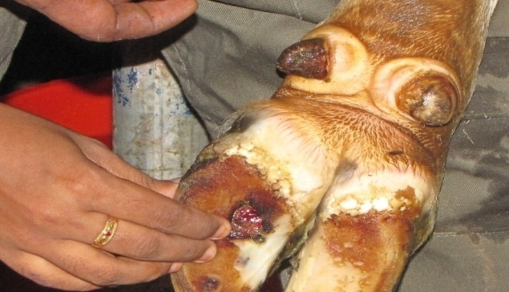
Heat stress symptoms in diary
Direct and Indirect Effects
The effect of animal production in the hot humid climate has global significance in the light of climate change threats. Effects of increasing effective temperature, droughts, increasing salinity of inland water bodies, deforestation and pollution are concerns of subtropical and even temperate regions due to possible fallout of global climate change.
Direct Effects

Direct effects include multiple stresses due to temperature, humidity, radiation, low plane of nutrition, heavy rains, pests and diseases. The cyclical phenomenon of drought and floods has additional effects. The indirect effect of climate is the reduced availability of quality feed ingredients. Direct and indirect effects cause stress which cause depletion of body reserves and there by reduced production, growth and reproduction. Among all stresses that the climate offers, the thermal stress due to effective environmental temperature in the most important. Challenge before the scientific community of the tropical world is to find ways to enhance milk production in the prevailing climatic conditions. Historically the traditional livestock production largely depended on heat tolerant native breeds that produced less milk compared to temperate exotic breeds. The dairy sector now largely comprises of extensive and expanding crossbred population in Kerala. For crossbreds, increased air temperature, and humidity measured as Temperature Humidity Index (THI) above critical thresholds are related to low dry matter intake (DMI) and to reduced efficiency of milk production cause significant heat stress. The daily mean Temperature Humidity Index (THI) at selected locations over Kerala is depicted in Fig. 1. The result indicated that THI may not be conducive from February to May.
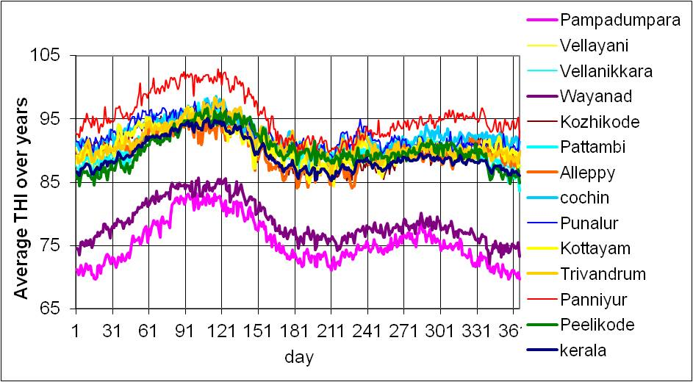
Fig. 1 Daily mean Temperature and Humidity Index (THI) at selected locations across Kerala

The Zone of Thermo-neutrality with in which no additional energy above maintenance is expended to heat or cool the body- for livestock is between -0.5 to 20⁰C and the upper critical temperature (B on the right side) may reach to 25-26⁰C (West, 2003). The ambient temperature of hot humid region is above this critical temperature during several months of each year. Effective environmental temperature is a combined effect of ambient temperature and humidity (Fig.2). The combined effect is quantified as Temperature Humidity Index (THI) . The normal THI to maintain production in dairy cattle is 72. In our state, during most days in a year it is hot and humid and hence the THI is high enough to cause significant heat stress.
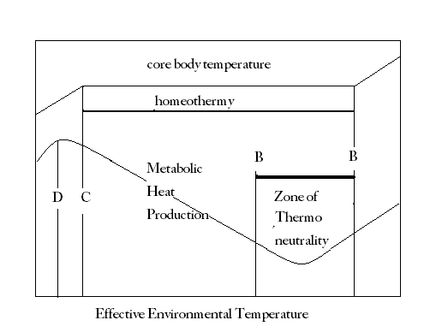
Fig. 2 Kleiber’s law of metabolic heat production and core body temperature as influenced by environment temperature

C = lower critical temperature
D = point of reduction of metabolic heat
B on the left side = lower point of zone of thermal neutrality below which chemical regulation is needed to maintain homeothermy.
B on the right side = upper critical temperature.
Heat distress on animals will reduce the rate of animal feed intake and causes poor performance growth (Rowlinson, 2008). Among the direct effects of climate change most significant is the reduced milk production at higher temperatures. The following chart adapted from Esmay 1961 based on studies conducted in Psychrometric chamber shows reduction in milk production in breeds which incidentally forms the parent sires used for crossbreeding activity of Kerala (Fig. 3). The following chart adapted from Esmay 1961 based on studies conducted in Psychrometric chamber shows reduction in milk production in breeds which incidentally forms the parent sires used for crossbreeding activity of Kerala.
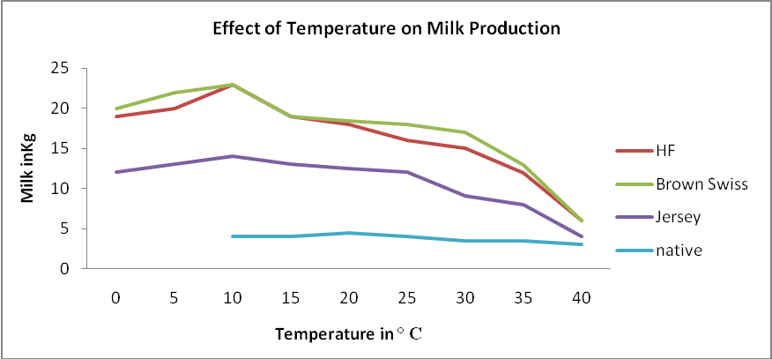

Fig. 3 Effect of temperature on milk production

Indirect Effects

Earth’s Climate is undergoing noteworthy changes. The frequency and severity of risks in agriculture particularly in last few decades have increased on account of climate variability. The dependence of Indian agriculture on climate, weather, rainfall and the timeliness of rainfall is substantial. The principal evidence of climatic change has been rising temperatures, erratic rainfall pattern, and increase in the severity of droughts, floods, and cyclones which have caused huge losses in agricultural production and the livestock population. The climate change, especially global warming is now well documented Projected climate change over India based on various models suggest steady increase in temperature and at a later stage slight increase of rainfall. Climate change will have far-reaching consequences for dairy, meat and wool production mainly via impacts on grass and range productivity. Changes in rainfall patterns may translate to an increased spread of existing vector-borne diseases and macro parasites of animals as well as humans with the emergence and spread of new diseases. In some areas, climate change may also cause new transmission models; these effects has already experienced in Kerala with the increasing density of mosquito population and a variety of fever outbreaks. In spite of the major impact of climate change on livestock sector and the direct contribution of this sector to climate change not many studies has been undertaken in this area in Kerala. A few studies have been reported on the effect of extreme climates on production performance of livestock. Studies on the physiological sturdiness with respect to adaptability of cross bred animals (sahiwal brownswiss crossbreds) in comparison to native zebu cattle indicated that the cross bred could face the thermally adverse climate in tropics successfully and can perform in hot humid areas. Based on this research he recommended some simple effective management procedures for the cross bred animals under the tropical and sub tropical conditions like providing shelter during day time, night feeding, feeding roughages in the evening. From his study he could evolve a modified tolerance index for tropics. He has made elaborate studies on the problem of dairying in hot humid climate and developed a formula for Temperature Humidity Sunshine Index (THSI) which is a modification of THI (Temperature humidity Index (Thomas, 1969). In another study by Rajagopalan (1975) to evaluate the performance of Jersey cattle in Indian conditions, it was found that Jersey animals are quite suitable for cross breeding programme in view of their high average performance level under local climatic conditions in India. Thiagarajan (1989) in his work has attempted to investigate the effects of housing and feeding on growth and production of B. Taurus * B. indicus cross bred cattle. He has studied the beneficial effects of open air conditions in hot humid tropical environment and advised loose housing system in hot humid tropical environment in which cattle have continuous access to open paddock shaded by trees. Under the hot humid conditions high wind velocity in the open seems to favour the cows considerably. Study by Suraj and Sivakumar, (2012) suggests that the environment in which the dairy cattle are reared affects its ability to maintain thermal balance. It was found that the climatic condition of the different zones and the choice of materials played a major role in deciding the comfort level of the animal in the individual housing system. The analysis based on Temperature Humidity Index of Kerala for the last 10 years has revealed that climatic stress is very high in most parts of the state throughout the year (unpublished data, Prasad, 2013). Indo Swiss Project in 1963 contemplated to involve a new multipurpose breed suitable for the climatic conditions prevailing in Kerala. Integrated Cattle development project (ICDP) plan was mooted for the fourth five year plan. Increase in animal population has also been attributed as a cause for climatic change. The increase in global average temperature is due to the observed increase in anthropogenic greenhouse gas concentrations. The global livestock sector generates directly or indirectly 18% of global greenhouse gas (GHG) emissions as measured in CO₂ equivalent (FAO, 2007). Considering the large population of livestock, most of the developed countries were complaining about the GHG emission from Indian livestock. Commercial livestock farming has not emerged as a successful model in Indian condition due to various reasons. The varying environmental factors and the inability to devise and to popularize cost effective adaptation methodologies contribute to this factor. However, the small holder production system prevailing in the country has the advantage of reduced GHG because of dung distributed in the pasture during grazing.
Future Line of Work
- To analyze and update the trends in climatic changes and to integrate the information to develop a database

- to forecast extreme weather events which can be detrimental to livestock farming by using computer simulation tools

- to study the impact of climatic change on production and reproduction performance of animals.

- To study the decline in disease resistance as well as emerging new diseases on basis of changing climate of Kerala

- To sort out suitable mitigation measures to the changing climate so that the livestock farming sector of Kerala is not affected by the climatic variation
- Assisting the farmers in developing and adopting appropriate measures and management schemes in changing climate scenario

- Immediate reasons for climate change should be traced out and effort should be taken to develop measures to mitigate the production of greenhouse gas emissions from livestock

Though Kerala has achieved much in crossbreeding of cattle compared to other states of India, the average milk production of the cows is much less than its genetic potential. Improved production potential and sustainability in production in the prevailing climate should be supported by scientific research and this field will be of more importance in the background of climate change. Soil degradation through use of agro-chemicals is a serious issue that needs to be addressed on a priority basis in India during the next five-year plan. Imbalanced use of chemical fertilizer has led to declining fertilizer response in the fertile irrigated regions. Excess use of some nutrients, driven in part by imbalanced subsidies, has led to depletion of other nutrients from the soil leading to deterioration of the soil health. Alarmingly, the drastic decrease in the organic carbon content of the soil and the change in C: N ratio is one of the major reasons for soil degradation and decrease in agricultural productivity. The nature and extent of problem differ in different of parts of the country.
The carbon sequestration potential by cultivatable fodder plots could be used to partly mitigate the greenhouse gas emissions of the livestock sector. This will require avoiding land use changes that reduce ecosystem soil carbon stocks and a cautious management of fodder plots aiming at preserving and restoring soils and their soil organic matter content. Trade-offs between greenhouse gas emissions and animal production need to be better understood at the farm and regional scales, through a continued development of observational, experimental and modeling approaches (Soussana, 2010). Development of appropriate cost effective technologies for climate change mitigation, conservation of natural resources and ensuring the livestock productivity is very important from social and economic point of view.
Suggested Readings
Esmay ML 1978. Principles of Animal Environment, AVI publishing Company, Connecticut, 351 p.

IPCC (Intergovernmental Panel on Climate Change). 2007. Climate change 2007: the physical science basis. Contribution of Working Group I to the Fourth Assessment Report of the Intergovernmental Panel on Climate Change [S. Solomon, D. Qin, M. Manning, Z. Chen, M. Marquis, K.B. Averyt, M. Tignor & H.L. Miller, eds.]. Cambridge, UK, Cambridge University Press in The Hindu, pp 147-155.

Rajagopalan T G 1974. Study of some aspects of the performance of Jersey cattle. MSc Thesis submitted to Gujarat College of Veterinary Science and Animal Husbandry, Anand.
Ramakrishna, Y. S., Rao, G.G.S.N., Rao, S. G. and Vijayakumar, P. 2006. Impact of climate change in Agriculture. In: Environment and Agriculture (eds. Chadha, K.L. and Swaminathan, M.S.). Malhotra Publishing House, New Delhi, pp. 1-30.

Rao, G. S. L. H. V. P. 2008. Agricultural Meteorology. PHI Publications. New Delhi. 364p.

Rao, G. S. L. H. V. P., Rao, G. G. S. N. and Rao, V. U. M. 2010. Climate Change and Agriculture over India. PHI Publications. New Delhi.

Rowlinson, P. 2008. Adapting livestock production systems to climate change – temperate zones. In: P. Rowlinson, M. Steele & A. Nefzaoui, eds. Livestock and global change.Proceedings of an international conference, Hammamet, Tunisia, 17–20 May 2008. Cambridge, UK, Cambridge University Press. 61-63.

Shashi, K., Pathak and Mason, N. J. 2002. Our shrinking ozone layer: General perspectives and remedial measure. Resonance, December pp.71-80.

Shukla, P. R., Sharma, S. K and Ramana, V. P. 2002. Climate Change and India - Issues, Concerns and Opportunities. Tata – McGraw-Hill Publishing Company Ltd, New Delhi, 314p.

Soussana, J. F., Tallec, T. and Blanfort, V. 2010 Mitigating the greenhouse gas balance ofruminant production systems through carbon sequestration in grasslands. Animal 4:3, 334-350.

Suraj, P. T. 2011. Effect of dairy cattle under different housing pattern in north and western regions of Tamilnadu. PhD thesis submitted to Tamilnadu Veterinary and Animal Sciences University.

Thiagarajan, M. 1989. Effect of environmental heat stress on performance of crossbred dairy cattle. PhD thesis submitted to Kerala Agricultural University.

Thomas C .K. and Sastry, N. S. R. 1991. Dairy Bovine Production (first ed.). Kalyani Publishers, New Delhi, pp 106-125 .

West, J. W. 2003. Effects of heat-stress on production in dairy cattle. J. Dairy Sci., 86, 2131-2144.

Introduction to Livestock Meteorology

The science of Meteorology is defined as the science that deals with the physical and chemical processes of the lower atmosphere. The physical and chemical changes in the lower atmosphere produce weather and popularly known as the weather science. The weather science concerns the study of structure, state and behaviour of the lower atmosphere. It is essentially an observational science dealing with different atmospheric variables such as atmospheric pressure, temperature, wind, humidity, density, cloud amount, radiation, precipitation and related variables at a given moment. It attempts to predict the behaviour of the atmosphere over a period of few hours to few days ahead and disseminate the same in time to the users’ community. The statistical approach of weather phenomena deals with the mean state of the physical properties of atmosphere. This branch of science is popularly known as Climatology. The weather science can be categorized into several branches based on method of approach, purpose and function, scale and region. Based on the purpose and function, it can be divided into several branches like Livestock Meteorology, Agro Meteorology, Forest Meteorology, Hydro Meteorology (Fig 1.1).
Meteorology
Livestock Meteorology
- deals with animal
agriculture

Agro Meteorology
- deals with
agriculture

Forest Meteorology- deals with forests, forest fires, wild life and zoonosis
agriculture

Agricultural Meteorology
Hydro Meteorology
- deals with water

Fig 1.1 Origin of science of Livestock Meteorology
Livestock Meteorology
Livestock Meteorology is the science which deals with the physical characteristics of the environment of animal species/organisms. It is concerned with the physical processes of the surrounding environment, which can be exploited in the interest of animal agriculture to increase animal products in terms of quantity as well as quality. It is also concerned with the interactions between meteorological factors on the one hand and animal agriculture (animal husbandry) on the other hand. In other words, livestock meteorology is defined in simple terms as the science which deals with the influence and interactions between weather elements and animal husbandry.
Meteorology and Livestock Meteorology
The science of Meteorology and Livestock Meteorology can be differentiated based on its functions and purposes. While Meteorology is a branch of lower atmospheric physics Livestock Meteorology is a branch of applied meteorology or a branch of animal agriculture as it deals with interactions between weather elements and animal husbandry. Similarly, weather service is the concern of the science of Meteorology while livestock advisory based on weather forewarning is the concern of the science of Livestock Meteorology. Like that, it can be differentiated in many ways based on observations, experiments, experience and relevance (Table 1.1).
Table 1.1 Difference between Meteorology and Livestock Meteorology
Meteorology | Livestock Meteorology
It is a branch of lower atmospheric physics | It is a branch of applied meteorology or a branch of animal agriculture as it deals with animals
It is a weather science | It is a product of animal agriculture and meteorology
It is a physical science | It is a biophysical science
It aims at weather forecasting | It aims at improving quantity and quality of animal agricultural production through meteorological skills
Weather service is the concern | Livestock advisory service to the livestock farmers is the concern based on weather forewarning
It is a linking science to the society | It is a linking science to the livestock farming community

Greenhouse Effect
Carbon dioxide, water vapour, methane, carbon monoxide, sulphur and nitrous oxides, chloroflurocarbons and cholorofluromethanes are the atmospheric constituents of major importance. Incoming shortwave radiation is not absorbed by the above atmospheric constituents, and the outgoing long wave radiation from the earth is absorbed by them and reradiate back to the earth surface. In the process, earth warms up and its temperature rises. It is known as the greenhouse effect. It is also known as the glasshouse effect as an important property of glass is that it allows solar radiation through it and disallows longwave radiation from the earth; thereby warming takes place. The atmospheric constituents which have the property of absorbing longwave radiation and transparent to shortwave radiation are known as the greenhouse gases (GHG). Human activities like fossil fuel combustion, production of synthetic chemicals, biomass burning, deforestation, excess use of chemical fertilizers, and use of pesticides change the chemical composition of the atmosphere, thereby enhancing the greenhouse effect. The ozone-friendly substitutes such as chloroflurocarbons (CFCs), hydroflurocarbons (HFCs), hydrochloroflurocarbons (HCFCs) and perflurocarbons (PFCs) and cholorofluromethanes (CFMs) are also powerful greenhouse gases contribute to the greenhouse effect and thus global warming. Of course, the methane emissions from animal agriculture are the concern in climate change mitigation.
Weather and Climate
Weather decides animal production and thereby animal productivity while climate decides selection of animals. Similarly, animal pest and disease incidence and spread is dependent on weather while the hot spot areas of animal diseases can be delineated based on climate (Table 1.2 ). The tropical, temperate and polar animals are classified on the basis of the thermal and precipitation regimes across the globe, rather mostly based on thermal regimes.
Table 1.2 Difference between weather and climate
Weather | Climate
Refers to physical state of atmosphere at a given time in terms of temperature, rainfall, relative humidity, sunshine hours and so on. | Refers to average state of weather  (Required at least 30 years of weather data to find out the climate normals) – Ex. Rainfall and temperature normals
Decides animal behaviour and thereby milk productivity in the case of cattle and related animals | Decides geographical distribution of animals and integrated farming systems (Eg. tropical , sub-tropical, temperate and polar animals)
Day to day livestock farming is dependent on weather | Livestock farming is dependent on climate
Animal pest and disease incidence is dependent on weather | Hot spot areas of animal pest and disease incidence and their geographical distribution can be delineated based on climate
Extremes like floods and droughts and cold and heat waves depend on weather | Extreme weather prone areas can be delineated based on climate.  Climate decides sea level rise

Weather
The physical state of atmosphere at a given point in time at a given location is referred to as ‘weather’. Weather is described in terms of the instantaneous or short period of mean value of the various atmospheric variables such as atmospheric pressure, temperature, humidity, cloudiness and sunshine, evaporation and rainfall. Weather determines the day-to-day livestock farming operations and comfort and discomforts.
Climate
Climate is the long-term regime of the atmospheric variables, or the composite of the day-to-day values of the weather elements over a long period of a given place or area. The period of averaging weather may be several days, weeks, months, years or even centuries in the event of climate change. The climate is represented based on the normal values worked out for a period of 30 years, which is considered as the standard to express climatic conditions for a given place. The India Meteorological Department (IMD) used to prepare climate normals for every 30 - year period since 1901.
Importance of Livestock Meteorology

The success or failure of animal agriculture depends upon the chain of several factors viz. breed, fodder and nutrition management, environment and its interactions including weather, technology and live stock farmer. Any weak link in the chain finally determines the animal output. Livestock farmers are encountering new challenges in terms of shortage of labourers, rise in production costs, uncertain markets and more recently, increased weather/climate risks. It is seen that extreme events such as floods and high intensity single day rainfall events and prolonged summer droughts/dry spells and heat and cold waves were on increasing trend from the last one-and-half-a-decades in a projected climate change scenario. Life cycles of animals, reptiles and birds are likely to be adversely affected due to rising mercury in addition to mortality due to heat stress. Animal raids in farmsteads and attacks in peripherals have not become uncommon due to deforestation. The human and wildlife conflicts due to deforestation and temperature rise are likely to emerge under the projected climate change scenario in the ensuing decades. Climate change also affects animal diseases and their dynamics. Interactions of animal insect pest and diseases are likely among various life species and thus the scenario of major and minor animal pest and diseases is likely to change. Vulnerability to extreme events generally is higher than vulnerability to changing average climatic conditions. The economy is likely to hit badly during the years of weather abnormalities. Prolonged summer drought, followed by heavy floods during the monsoon season as noticed in 2013 across the State of Kerala was detrimental to dairy, pig, goat and poultry farming directly or indirectly to a considerable extent. Of course, flood damage is not uncommon during both the monsoon seasons in high rainfall zones. Such weather aberrations are likely to be more frequent under the projected climate change scenario. Therefore, it is high time to take up in detail studies on interactions between weather factors in surrounding environment of animal agriculture, for which fundamental and basic studies need to be carried out in Livestock Meteorology to cope up with climate variability/climate change adaptation and mitigation.

Scope of Livestock Meteorology

Livestock Meteorology is a multidisciplinary science. Though it is a branch of applied meteorology dealing with interactions between atmospheric variables and animal husbandry it interacts with the disciplines related to animal agriculture viz. Livestock Production Management, Nutritional Management, Animal Physiology and Reproduction, Animal Diseases, and other allied animal agricultural sciences (Fig. 1.2). Hence, Livestok Meteorology puts the science of meteorology to service of animal agriculture to help livestock farmers use their environment for producing more and more animal output in terms of quantity as well as quality. The scope of Livestock Meteorology could also be explained through different ways and means as indicated below:
- To characterize climatic resources of a given area for effective planning
- To evolve weather based effective live stock farm operations
- To study animal - weather relationships in all important animal species and forecast animal output
- To study the relationship between weather factors and incidence of pests and diseases of various animals and forewarn the incidence and spread based on weather forewarning
- To delineate climatic/agro ecological/agro climatic zones for defining agro climatic analogues so as to make effective and fast transfer of technology for improving animal output
- To prepare animal-weather-feed-disease diagrams and animal-weather-feed-disease calendars
- To develop and revalidate animal growth simulation models for assessing and obtaining potential yields in different agro climatic zones
- To understand the impact of climatic variability or climate change on animal agricultural produce including quality and project future trends
- To develop pro-active measures against livestock meteorological risks in varied climates
- To develop weather- based livestock advisories to sustain animal agriculture based on weather forewarning including seasonal climate forecasts
Livestock
Meteorology
Stress physiology and animal reproduction
Livestock production and nutritional management
Statistical methods
Animal breeding and genetics
Bio-technology
tools
Dairy farming
Poultry farming

Zoonosis
Livestock advisory based on weather forewarning
Epidemiology

Fig. 1.2 Scope of Livestock Meteorology

Livestock – Climate Information
The livestock climatic information is nothing but any information on climate/weather which is related to animal distribution and production including dairy and poultry farming. It helps in generating technologies for sustenance of animal agriculture in terms of quantity and quality. For example, the delineation of climatic zones is based on rainfall and temperature or some other integrated climate indices. It falls under the climatic information while the Temperature-Humidity Index (THI) is used to delineate comfort/discomfort zones for a particular animal agriculture it can be classified under livestock-climate information (Table 1.3 ).
Table 1.3 Difference between climatic and Livestock climatic Information
Climatic information | Livestock climatic information
Examples:  - Onset and withdrawal of monsoon Length of monsoon period  - Mean annual/seasonal rainfall  - Spatial and temporal distribution  - of rainfall, wind and temperature | Examples:  - In low rainfall states like Rajasthan, arid climates and sparse vegetation prevail. Animal agriculture in relation to arid climates is only possible (Camel and sheep)  - In high rainfall states like Kerala, humid climates and dense forests prevail. Animal agriculture in relation to humid climates is only possible ( ).
Climatic zones based on rainfall and temperature or climate indices  Types of climate | Livestock climatic zones based on vegetation, climate, topography and altitude and related to animal agriculture  Climatic zones with reference to a specific animal species

Environmental Stress in Animal Agriculture
The environmental stress, includes the biotic stress (pest and diseases), abiotic stress (influence of weather abnormalities), air pollution, ozone depletion and UV-radiation, livestock production and nutritional management practices, exerts on animal husbandry adversely to a considerable extent (Fig. 1. 3). The impact of these stresses on animal agriculture in varied climates need to be focussed through concerted research efforts.

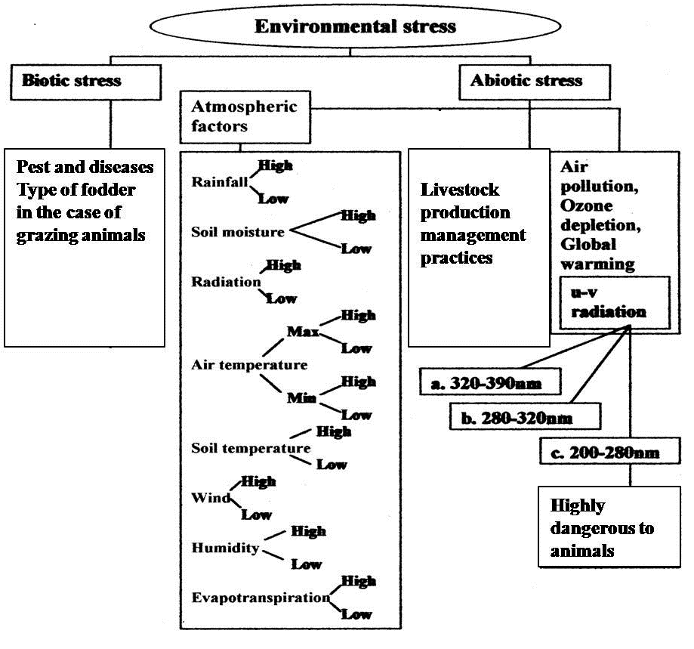
Fig. 1.3 Biotic and abiotic stresses in animal agriculture
Weather Abnormalities
Floods and droughts, cold and heat waves, cyclones and anticyclones, cloudbursts, lightning and thunderstorms, duststorms, icestorms and snowstorms, forest fire outbreaks and sea level rise can be classified under the weather related disasters while the Earthquakes and the Tsunami fall under natural disasters (Fig 1.4 ). Under the projected climate change scenario, the occurrence and intensity of weather abnormalities are likely to be more and more in the ensuing decades. The effects of drought may lead to scarcity of water and fodder during summer as seen in 1983, 2004 and 2013 in Kerala. It adversely affects fodder and dairy farming and the thermal stress during summer is detrimental to poultry farming as both the farming systems are sensitive to drought and heat stress. The occurrence of cold wave is relevant in the temperate regions of the central and northern regions of the Country while the heat wave conditions are prevalent outside the humid tropics (Kerala). However, continuous rainfall with high humidity and temperature always pose a problem in animal agriculture in the humid tropics and efforts are needed in this direction to understand the discomfort and its effects based on rainfall, humidity and temperature (THI) in animal agriculture.

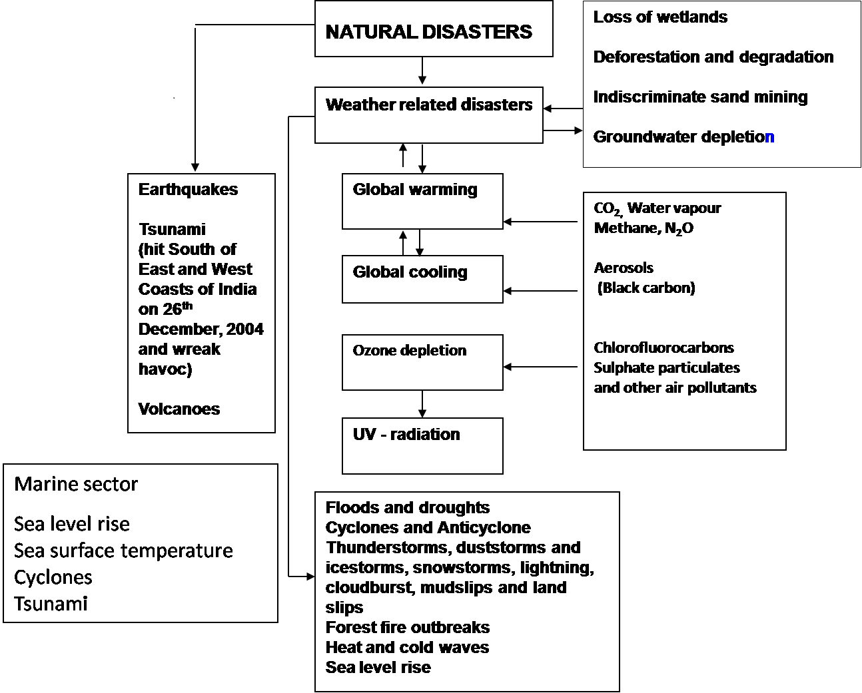
Fig. 1.4 Natural and weather related disasters

Altitudinal Sequence of Animal Species in Kerala
Atmospheric temperature is influenced with altitude. It decreases with height as per the lapse rate. The lapse rate is nothing but decrease in air temperature at the rate of 6.5ºC/km with height. It is true in the atmospheric layer (Troposphere) above the Earth surface at which all the living/animal organisms survive. At the same time, the kind of animals which can survive varies depending upon the thermal regime which is reflected with the altitude. The author would like to focus in this direction to understand the influence of altitude on the existence of type of animals. It may be incomplete or requires close examination and subject to modification. Similarly, the kind of animals can be specified with altitude, though it is a complex one, within the tropics/sub-tropics/temperate/polar regions.
Table 1.4 Altitudinal sequence of animals species in
Class | Region | Temperature conditions | Altitude (amsl) | Animal species
Mega- therms | Low land | High to Moderate temperature throughout the year | 0 -10 m | Cattle, goat
Meso- therms | Mid land | Moderate temperature throughout the year, winter temperature relatively low | 10 -100 m | Cattle, goat
Micro- therms I | High land | Moderate to Low temperature throughout the year, winter temperature low | 100 -500 m | Cattle, goat
Micro- therms II | High land | Low temperature throughout the year | 500-1000 m | Cattle, goat
Micro- therms III | High ranges | Low temperature throughout the year, winter temperature is occasionally goes below 0°C | 1000-2500 m | Cattle, goat, elephant

Seasons
Radiation received from the sun is the main source of earth’s atmospheric energy and ultimately it is the fuel of the atmosphere. The atmosphere acts mostly as the medium which is transparent to the sun’s radiation and opaque to the earth’s radiation, and this is the driving force of atmosphere. Variations in radiation received over different regions of the globe due to its positioning with reference to the sun, together with the features of the earth, produce weather and climate. The seasons form due to the revolution of the earth round the sun. Tilt of the Earth, revolution of the Earth and the North Pole of the Earth always points in the same direction make the seasons different across the Globe. When the Northern Hemisphere experiences six month summer the Southern Hemisphere experiences winter and the opposite happens for the remaining six months. While the seasons in UK/USA are: Spring- March to May; Summer-June to August; Autumn- September to November; and Winter- December to February. The seasons in India based on temperature and precipitation are as follows:

Summer- March to May (Temperature); Monsoon-June to September (Rainfall); Post monsoon-October to November (Rainfall) and Winter-December to February (Temperature).The monsoon and post monsoon seasons in Kerala are similar to that of the Country. Winter season also is similar across the high land and high ranges. Across the low and mid lands of Kerala, winter is very mild and one can consider December and January months in winter whereas February and March falls under the real summer in low lands and temperature falls drastically during April and May depending on the pre-monsoon showers and onset of monsoon. Therefore, one should be careful while interpretation seasonal variations for comparison.

Status of Meteorology and Livestock Meteorology

The Indian Meteorological Department (IMD), Government of India, is the unique institution in the country which caters to weather services. It was established in 1875. The headquarters of the IMD are located in New Delhi. The IMD headquarters are known as Mausam Bhavan. Its role in weather forecasting is tremendous. The National Data centre (NDC) created at IMD, Pune in 1977, where large series of climatological data are maintained in computerised form from 1875 onwards. The Indian Institute of Tropical Meteorology (IITM), located in Pune, is another premier institution in the field of meteorological research in the Tropics. The “National Centre on Climate Change Research” has been established very recently and attached to IITM to take up modelling and other aspects in relation climate change studies. The research findings on climate change from IITM are included in the Intergovermental Panel on Climate Change (IPCC). However, studies in India in the direction of Livestock Meteorology are scanty though a few National Institutes/State Veterinary and Animal Sciences Universities commenced research on climate adaptation in animal agriculture. It is high time to initiate basic studies to understand the interactions between weather elements and animal husbandry including animal disease forewarning. Finally, the goal of livestock meteorology is to develop livestock advisory based on weather forewarning on research and operational mode for the benefit of livestock farming community and sustenance of livestock products under the projected climate change scenario.
References/Suggested Readings
Ahrens, C.D. 2000. Meteorology Today-An Introduction to weather, Climate and the Environment. 6th ed., Brooks/Cole, California, 528p.

Ghadekar, A. E. 2001. Meteorology. Agromet Publishers, Nagpur, 251p.

Gopalaswamy, N. 1994. Agricultural Meteorology. Rawat Publications, Jaipur, 153p.

Kakde, J.R. 2006. Agricultural Climatology. Metropolitan Book Company, New Delhi, 387p

Kumar, K. R., Kumar, K. K., Ashrit, R. G., Patwardhan, S. K and Pant, G. B. 2002. Climate change in India: Observation and model projections. Climatic change and India-Issues, concerns and opportunities (eds. Shukla, P.R., Sharma, K.S and Ramana, P.V.). Tata McGraw-Hill Publishing Company Limited, New Delhi, 24-75pp

Lutgens, F.K. and Tarbuck, E. J. 1998. THE Atmosphere. 7th ed., Prentice-Hall Inc.,London, 434p.

Menon, P. K. 1998. Our Weather. National Book Trust, New Delhi, 349p.

Rao, G. S. L. H.V. P. 2008. Agricultural Meteorology. Prentice – Hall of India Private Limited, New Delhi, 366p

Rao, G. S. L. H. V. P. 2011. Climate Change Adaptation Strategies in Agriculture and Allied Sectors. Scientific Publishers, Jodhpur (India), 330p

Rao, G. S. L. H. V. P., Rao, G. G .S. N. and Rao, V. U .M. 2010. Climate Change and Agriculture over India. PHI Learning Private Limited, New Delhi, 352p

Riehl, H. 1954. Introduction to Climate, McGraw-Hill, New York, 395p.

